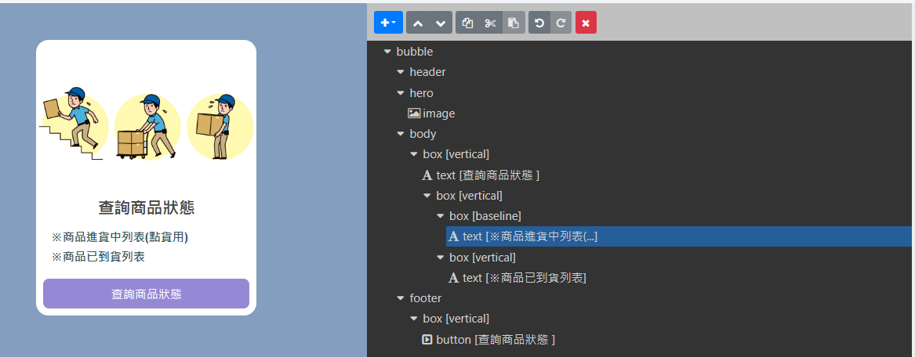

{

"type": "bubble",

"hero": {

"type": "image",

"aspectRatio": "20:13",

"url": "https://i.imgur.com/bRj2IM8.jpg",

"align": "center",

"margin": "none",

"animated": true,

"aspectMode": "cover",

"size": "full",

"offsetTop": "xxl"

},

"body": {

"type": "box",

"layout": "vertical",

"contents": [

{

"type": "text",

"text": "查詢商品狀態 ",

"weight": "bold",

"size": "xl",

"align": "center"

},

{

"type": "box",

"layout": "vertical",

"margin": "lg",

"spacing": "sm",

"contents": [

{

"type": "box",

"layout": "baseline",

"spacing": "sm",

"contents": [

{

"type": "text",

"text": "※商品進貨中列表(點貨用)",

"color": "#3b5a5f",

"size": "md",

"flex": 5,

"weight": "bold"

}

]

},

{

"type": "box",

"layout": "vertical",

"contents": [

{

"type": "text",

"text": "※商品已到貨列表",

"color": "#3b5a5f",

"size": "md",

"flex": 5,

"weight": "bold"

}

]

}

]

}

]

},

"footer": {

"type": "box",

"layout": "vertical",

"spacing": "none",

"contents": [

{

"type": "button",

"style": "primary",

"action": {

"type": "message",

"text": "進貨商品狀態查詢 ",

"label": "查詢商品狀態 "

},

"height": "sm",

"color": "#9589D6"

}

],

"flex": 0,

"margin": "none"

}

}